**Assignment No.10**

**Roll No:-**

**Q. Write ASP.NET program to demonstrate Client-Side State Management.**

**1)Design Code:- (***CookiesDemo.aspx***)**

<%@ Page Language="C#" AutoEventWireup="true" CodeBehind="CookiesDemo.aspx.cs" Inherits="ClientSideState.WebForm1" %>

<!DOCTYPE html>

<html xmlns="http://www.w3.org/1999/xhtml">

<head runat="server">

<title></title>

<style type="text/css">

.auto-style1 {

width: 100%;

}

.auto-style2 {

width: 182px;

}

.auto-style3 {

width: 153px;

}

.auto-style4 {

width: 182px;

height: 30px;

}

.auto-style5 {

width: 153px;

height: 30px;

}

.auto-style6 {

height: 30px;

}

</style>

</head>

<body>

<form id="form1" runat="server">

<div>

&nbsp;&nbsp;&nbsp;&nbsp;&nbsp;&nbsp;&nbsp;&nbsp;&nbsp;&nbsp;&nbsp;&nbsp;&nbsp;&nbsp;&nbsp;&nbsp;&nbsp;&nbsp;&nbsp;&nbsp;&nbsp;&nbsp;&nbsp;&nbsp;&nbsp;&nbsp;&nbsp;&nbsp;&nbsp;&nbsp;&nbsp;&nbsp;&nbsp;&nbsp;&nbsp;&nbsp;&nbsp;&nbsp;

<asp:Label ID="Label5" runat="server" Font-Bold="True" Font-Size="X-Large" Text="Client Side State Management"></asp:Label>

(Cookies)</div>

<table class="auto-style1">

<tr>

<td class="auto-style2">

<asp:Label ID="Label1" runat="server" Font-Bold="True" Font-Size="X-Large" Text="UserName:"></asp:Label>

</td>

<td class="auto-style3">

<asp:TextBox ID="TextBox1" runat="server"></asp:TextBox>

</td>

<td>

<asp:Label ID="Label3" runat="server" Font-Bold="True" Font-Size="X-Large"></asp:Label>

</td>

</tr>

<tr>

<td class="auto-style2">

<asp:Label ID="Label2" runat="server" Font-Bold="True" Font-Size="X-Large" Text="Password:"></asp:Label>

</td>

<td class="auto-style3">

<br />

<asp:TextBox ID="TextBox2" runat="server"></asp:TextBox>

</td>

<td>

<asp:Label ID="Label4" runat="server" Font-Bold="True" Font-Size="X-Large"></asp:Label>

</td>

</tr>

<tr>

<td class="auto-style4">&nbsp;&nbsp;&nbsp;&nbsp;&nbsp;&nbsp;&nbsp;&nbsp;&nbsp;&nbsp;&nbsp;

<asp:Button ID="Button1" runat="server" Font-Bold="True" Font-Size="Large" Height="31px" OnClick="Button1_Click" Text="Set Cookies" Width="151px" />

</td>

<td class="auto-style5">

<br />

<asp:Button ID="Button2" runat="server" Font-Bold="True" Font-Size="Large" OnClick="Button2_Click" Text="Get Cookies" />

</td>

<td class="auto-style6"></td>

</tr>

<tr>

<td class="auto-style2">&nbsp;</td>

<td class="auto-style3">&nbsp;</td>

<td>&nbsp;</td>

</tr>

</table>

<div>

</div>

</form>

</body>

</html>

**Code:-**

*CookiesDemo.aspx.cs*

using System;

using System.Collections.Generic;

using System.Linq;

using System.Web;

using System.Web.UI;

using System.Web.UI.WebControls;

namespace ClientSideState

{

public partial class WebForm1 : System.Web.UI.Page

{

protected void Page_Load(object sender, EventArgs e)

{

}

protected void Button1_Click(object sender, EventArgs e)

{

Response.Cookies["uname"].Value = TextBox1.Text;

Response.Cookies["password"].Value = TextBox2.Text;

}

protected void Button2_Click(object sender, EventArgs e)

{

Label3.Text = Request.Cookies["uname"].Value;

Label4.Text = Request.Cookies["password"].Value;

}

}

}

**\*\*\*\*\*\*\*\*\*\*\*\*\*\*\*\*\*\*\*\*\*\*OUTPUT\*\*\*\*\*\*\*\*\*\*\*\*\*\*\*\*\*\*\***

**CookiesDemo.aspx:-**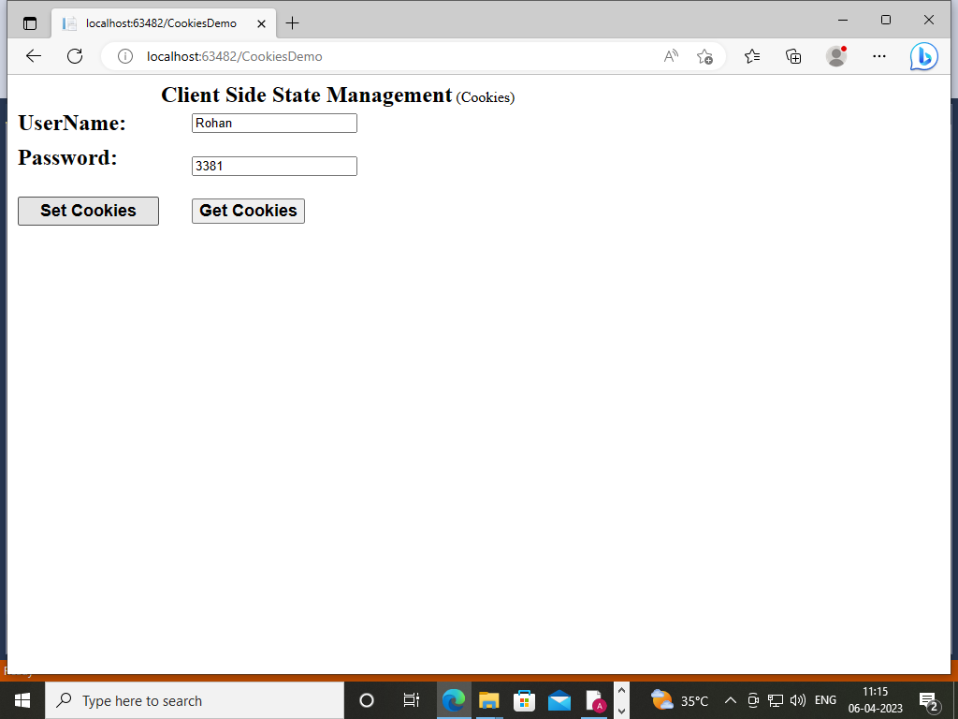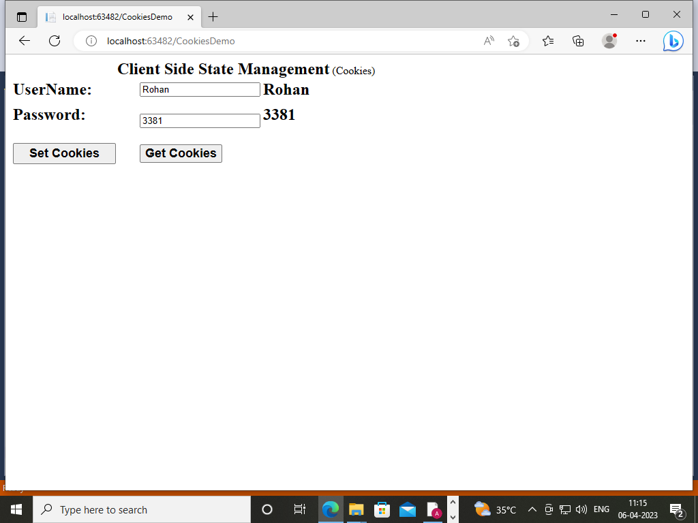

**2)Design Code:- (***ViewStateDemo.aspx***)**

<%@ Page Language="C#" AutoEventWireup="true" CodeBehind="ViewStateDemo.aspx.cs" Inherits="ClientSideState.ViewStateDemo" %>

<!DOCTYPE html>

<html xmlns="http://www.w3.org/1999/xhtml">

<head runat="server">

<title></title>

<style type="text/css">

.auto-style1 {

width: 100%;

}

.auto-style2 {

width: 182px;

}

.auto-style3 {

width: 153px;

}

.auto-style7 {

width: 182px;

height: 48px;

}

.auto-style8 {

width: 153px;

height: 48px;

}

.auto-style9 {

height: 48px;

}

.auto-style10 {

width: 182px;

height: 38px;

}

.auto-style11 {

width: 153px;

height: 38px;

}

.auto-style12 {

height: 38px;

}

</style>

</head>

<body>

<form id="form1" runat="server">

&nbsp;&nbsp;&nbsp;&nbsp;&nbsp;&nbsp;&nbsp;&nbsp;&nbsp;&nbsp;&nbsp;&nbsp;&nbsp;&nbsp;&nbsp;&nbsp;&nbsp;&nbsp;&nbsp;&nbsp;&nbsp;&nbsp;&nbsp;&nbsp;&nbsp;&nbsp;&nbsp;&nbsp;&nbsp;&nbsp;&nbsp;&nbsp;&nbsp;&nbsp;&nbsp;&nbsp;&nbsp;&nbsp;

<asp:Label ID="Label5" runat="server" Font-Bold="True" Font-Size="X-Large" Text="Client Side State Management"></asp:Label>

(ViewState)</div>

<table class="auto-style1">

<tr>

<td class="auto-style2">

<asp:Label ID="Label1" runat="server" Font-Bold="True" Font-Size="X-Large" Text="UserName:"></asp:Label>

</td>

<td class="auto-style3">

<asp:TextBox ID="TextBox1" runat="server"></asp:TextBox>

</td>

<td>

&nbsp;</td>

</tr>

<tr>

<td class="auto-style7">

<asp:Label ID="Label2" runat="server" Font-Bold="True" Font-Size="X-Large" Text="Password:"></asp:Label>

</td>

<td class="auto-style8">

<br />

<asp:TextBox ID="TextBox2" runat="server"></asp:TextBox>

</td>

<td class="auto-style9">

&nbsp;</td>

</tr>

<tr>

<td class="auto-style10">&nbsp;&nbsp;&nbsp;

<asp:Button ID="Button1" runat="server" Font-Bold="True" Font-Size="Medium" Height="31px" OnClick="Button1_Click" Text="Submit ViewState" Width="148px" />

</td>

<td class="auto-style11">

<asp:Button ID="Button2" runat="server" Font-Bold="True" Font-Size="Medium" Height="31px" OnClick="Button2_Click" Text="Restore ViewState" Width="173px" />

<br />

</td>

<td class="auto-style12"></td>

</tr>

<tr>

<td class="auto-style2">&nbsp;&nbsp;&nbsp;&nbsp;&nbsp;&nbsp;&nbsp;&nbsp;&nbsp;&nbsp;&nbsp;&nbsp;&nbsp;&nbsp;&nbsp;&nbsp;&nbsp;

<asp:TextBox ID="TextBox3" runat="server"></asp:TextBox>

</td>

<td class="auto-style3">&nbsp;&nbsp;&nbsp;&nbsp;&nbsp;&nbsp;&nbsp;&nbsp;

<asp:TextBox ID="TextBox4" runat="server"></asp:TextBox>

</td>

<td>&nbsp;</td>

</tr>

</table>

<div>

</div>

</form>

</body>

</html>

**Code: - (***ViewStateDemo.aspx.cs***)**

using System.Collections.Generic;

using System.Linq;

using System.Web;

using System.Web.UI;

using System.Web.UI.WebControls;

namespace ClientSideState

{

public partial class ViewStateDemo : System.Web.UI.Page

{

protected void Page_Load(object sender, EventArgs e)

{

}

protected void Button1_Click(object sender, EventArgs e)

{

ViewState["username"] = TextBox1.Text;

ViewState["password"] = TextBox2.Text;

}

protected void Button2_Click(object sender, EventArgs e)

{

if(ViewState["username"]!=null)

{

TextBox3.Text = ViewState["username"].ToString();

}

if (ViewState["password"]!= null)

{

TextBox4.Text = ViewState["password"].ToString();

}

}

}

}

**\*\*\*\*\*\*\*\*\*\*\*\*\*\*\*\*\*\*\*\*\*\*OUTPUT\*\*\*\*\*\*\*\*\*\*\*\*\*\*\*\*\*\*\***

**ViewStateDemo.aspx**

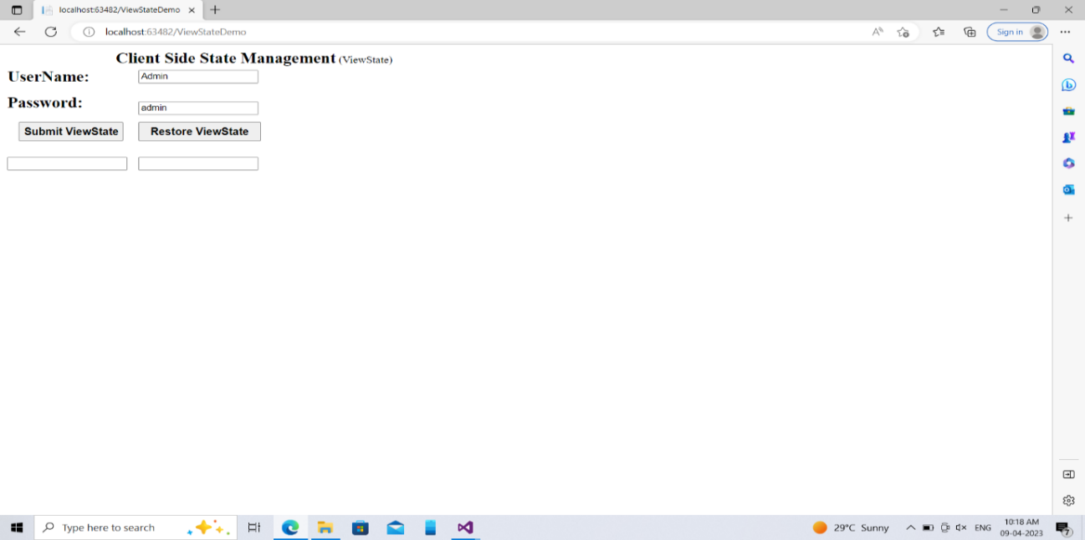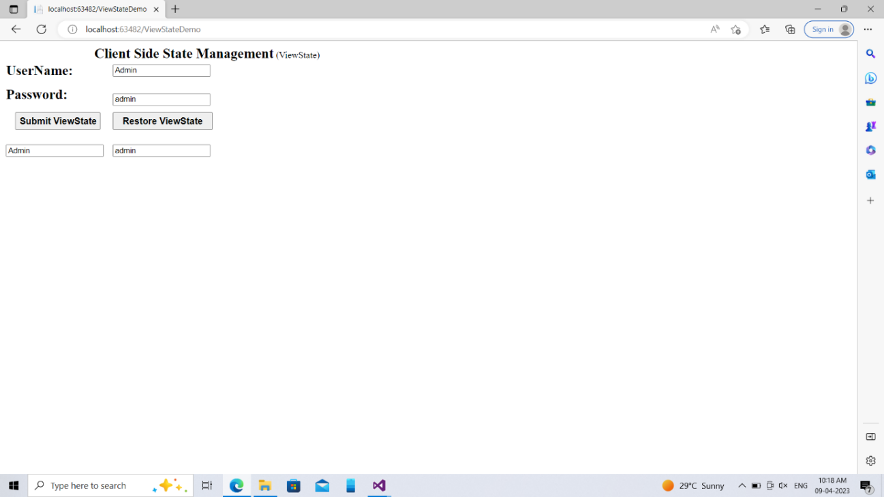

**3)Design Code:- (***QueryStringDemo.aspx***)**

<%@ Page Language="C#" AutoEventWireup="true" CodeBehind="QueryStringDemo.aspx.cs" Inherits="ClientSideState.QueryString" %>

<!DOCTYPE html>

<html xmlns="http://www.w3.org/1999/xhtml">

<head runat="server">

<title></title>

<style type="text/css">

.auto-style1 {

width: 100%;

}

.auto-style2 {

width: 178px;

}

.auto-style3 {

width: 231px;

}

</style>

</head>

<body>

<form id="form1" runat="server">

&nbsp;&nbsp;&nbsp;&nbsp;&nbsp;&nbsp;&nbsp;&nbsp;&nbsp;&nbsp;&nbsp;&nbsp;&nbsp;&nbsp;&nbsp;&nbsp;&nbsp;&nbsp;&nbsp;&nbsp;&nbsp;&nbsp;&nbsp;&nbsp;&nbsp;&nbsp;&nbsp;&nbsp;&nbsp;&nbsp;&nbsp;&nbsp;&nbsp;&nbsp;&nbsp;&nbsp;&nbsp;&nbsp;

<asp:Label ID="Label5" runat="server" Font-Bold="True" Font-Size="X-Large" Text="Client Side State Management"></asp:Label>

(QueryString)</div>

<table class="auto-style1">

<tr>

<td class="auto-style2">

<asp:Label ID="Label2" runat="server" Font-Bold="True" Font-Size="Large" Text="FirstName:"></asp:Label>

</td>

<td class="auto-style3">

<asp:TextBox ID="TextBox1" runat="server"></asp:TextBox>

</td>

<td>&nbsp;</td>

</tr>

<tr>

<td class="auto-style2">

<asp:Label ID="Label3" runat="server" Font-Bold="True" Font-Size="Large" Text="LastName:"></asp:Label>

</td>

<td class="auto-style3">

<asp:TextBox ID="TextBox2" runat="server"></asp:TextBox>

</td>

<td>&nbsp;</td>

</tr>

<tr>

<td class="auto-style2">&nbsp;&nbsp;&nbsp;&nbsp;&nbsp;&nbsp;&nbsp;&nbsp;&nbsp;&nbsp;&nbsp;&nbsp;&nbsp;&nbsp;&nbsp;&nbsp;&nbsp;&nbsp;&nbsp;&nbsp;&nbsp;&nbsp;&nbsp;&nbsp;&nbsp;&nbsp;&nbsp;

<asp:Button ID="Button1" runat="server" Font-Bold="True" OnClick="Button1_Click" Text="Submit QueryString" Font-Size="Medium" />

</td>

<td class="auto-style3">&nbsp;</td>

<td>&nbsp;</td>

</tr>

</table>

<br />

<br />

<br />

</div>

</form>

<p>

&nbsp;</p>

</body>

</html>

**Code: - (***QueryStringDemo.aspx.cs***)**

using System;

using System.Collections.Generic;

using System.Linq;

using System.Web;

using System.Web.UI;

using System.Web.UI.WebControls;

namespace ClientSideState

{

public partial class QueryString : System.Web.UI.Page

{

protected void Page_Load(object sender, EventArgs e)

{

}

protected void Button1_Click(object sender, EventArgs e)

{

Response.Redirect("Query.aspx?firstname=" + TextBox1.Text +" &lastname=" + TextBox2.Text);

}

}

}

***Query.aspx* : -**

<%@ Page Language="C#" AutoEventWireup="true" CodeBehind="Query.aspx.cs" Inherits="ClientSideState.Query" %>

<!DOCTYPE html>

<html xmlns="http://www.w3.org/1999/xhtml">

<head runat="server">

<title></title>

</head>

<body>

<form id="form1" runat="server">

<div>

<asp:Label ID="Label1" runat="server" Text="Label"></asp:Label>

</div>

</form>

</body>

</html>

***Query.aspx.cs* : -**

using System;

using System.Collections.Generic;

using System.Linq;

using System.Web;

using System.Web.UI;

using System.Web.UI.WebControls;

namespace ClientSideState

{

public partial class Query : System.Web.UI.Page

{

protected void Page_Load(object sender, EventArgs e)

{

string firstname = Request.QueryString["firstname"];

string lastname = Request.QueryString["lastname"];

Label1.Text = "Welcome " + firstname + " " + lastname;

}

}

}

**\*\*\*\*\*\*\*\*\*\*\*\*\*\*\*\*\*\*\*\*\*\*OUTPUT\*\*\*\*\*\*\*\*\*\*\*\*\*\*\*\*\*\*\***

**QueryStringDemo.aspx : -**

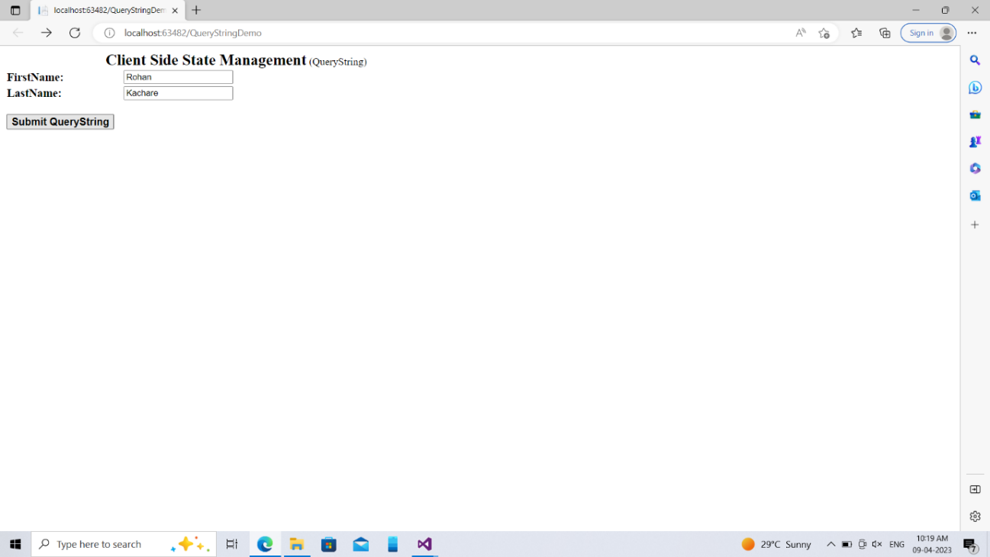

**Query.aspx**

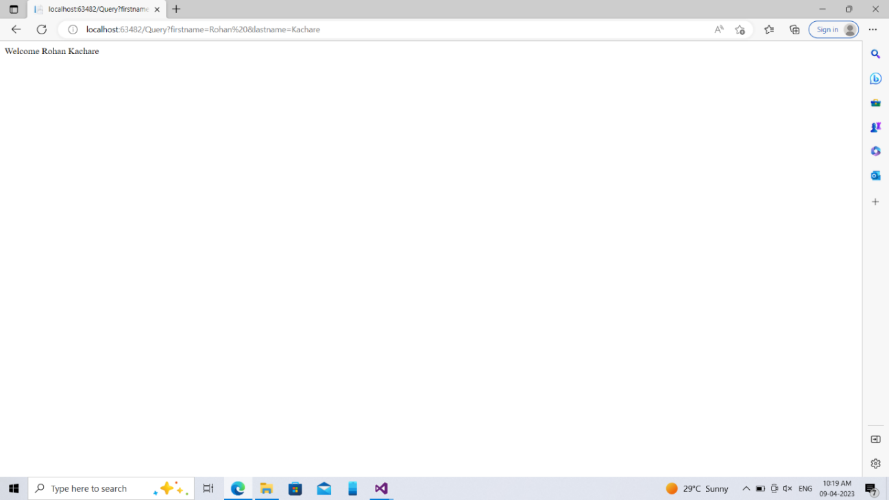

**4) Design Code : - (***HiddenFieldDemo.aspx***)**

<%@ Page Language="C#" AutoEventWireup="true" CodeBehind="HiddenFieldDemo.aspx.cs" Inherits="ClientSideState.HiddenFieldDemo" %>

<!DOCTYPE html>

<html xmlns="http://www.w3.org/1999/xhtml">

<head runat="server">

<title></title>

</head>

<body>

<form id="form1" runat="server">

<div>

<asp:HiddenField ID="HiddenField1" runat="server" OnValueChanged="HiddenField1_ValueChanged" Value="HF" />

&nbsp;&nbsp;&nbsp;&nbsp;&nbsp;&nbsp;&nbsp;&nbsp;&nbsp;&nbsp;&nbsp;&nbsp;&nbsp;&nbsp;&nbsp;&nbsp;&nbsp;&nbsp;&nbsp;&nbsp;&nbsp;&nbsp;&nbsp;&nbsp;&nbsp;&nbsp;&nbsp;&nbsp;&nbsp;&nbsp;&nbsp;&nbsp;

<asp:Label ID="Label2" runat="server" Font-Bold="True" Font-Size="Large" Text="Client Side State Management(HiddenFields)"></asp:Label>

<br />

<br />

&nbsp;&nbsp;&nbsp;&nbsp;&nbsp;&nbsp;&nbsp;&nbsp;&nbsp;&nbsp;&nbsp;&nbsp;&nbsp;&nbsp;&nbsp;&nbsp;&nbsp;&nbsp;&nbsp;&nbsp;&nbsp;&nbsp;&nbsp;&nbsp;&nbsp;&nbsp;&nbsp;&nbsp;&nbsp;&nbsp;&nbsp;&nbsp;&nbsp;&nbsp;&nbsp;&nbsp;&nbsp;&nbsp;&nbsp;&nbsp;&nbsp;&nbsp;&nbsp;&nbsp;&nbsp;&nbsp;&nbsp;&nbsp;&nbsp;&nbsp;&nbsp;&nbsp;&nbsp;&nbsp;&nbsp;&nbsp;

<asp:Label ID="Label1" runat="server" Font-Bold="True" Font-Size="Medium" Text="Label"></asp:Label>

</div>

</form>

</body>

</html>

**Code** : - (*HiddenFieldDemo.aspx.cs*)

using System;

using System.Collections.Generic;

using System.Linq;

using System.Web;

using System.Web.UI;

using System.Web.UI.WebControls;

namespace ClientSideState

{

public partial class HiddenFieldDemo : System.Web.UI.Page

{

protected void Page_Load(object sender, EventArgs e)

{

HiddenField1.Value = DateTime.Now.ToString();

Label1.Text ="HiddenFieldValue Is: "+ Convert.ToString(HiddenField1.Value);

}

protected void HiddenField1_ValueChanged(object sender, EventArgs e)

{

}

}

}

**\*\*\*\*\*\*\*\*\*\*\*\*\*\*\*\*\*\*\*\*\*\*OUTPUT\*\*\*\*\*\*\*\*\*\*\*\*\*\*\*\*\*\*\***

**HiddenFieldDemo.aspx:-**

